**ADS NYANZA SMS PLATFORM USER MANUAL**

# INTRODUCTION

The platform is a tool for communication to relevant people or groups with a view to share information mainly on health. The communication is basically done through sms(Short message service).

Some arrears have less or no internet coverage, this makes it difficult to access basic health information to the people. With the sms platform this information can be easily accessed.

# Main Menu

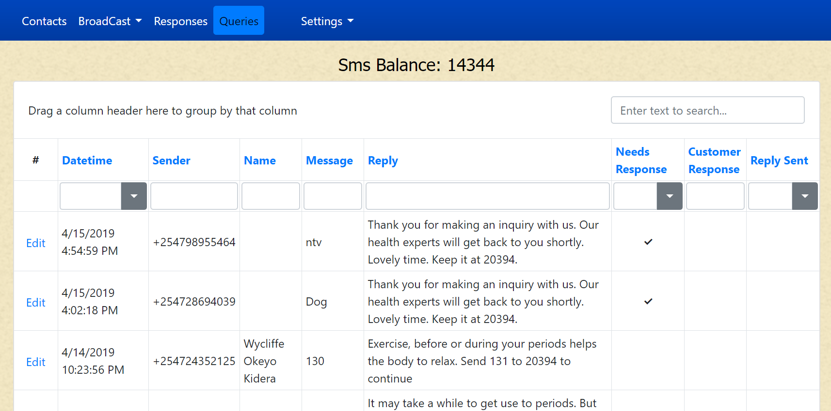

Search area

Information area

Sms Balance

Menu

# Contacts

* Click on the contacts in the menu.
* This will display contacts as below.

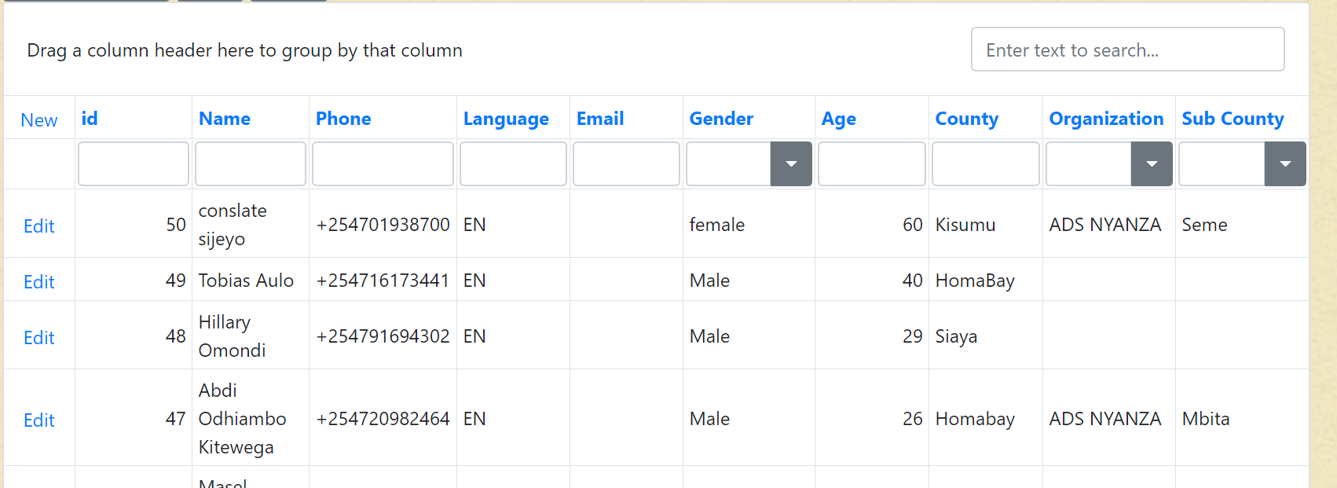

## Add Contacts

* Click on new on the left top side of the list

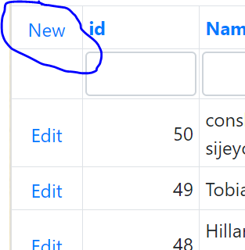

* The form below will appear

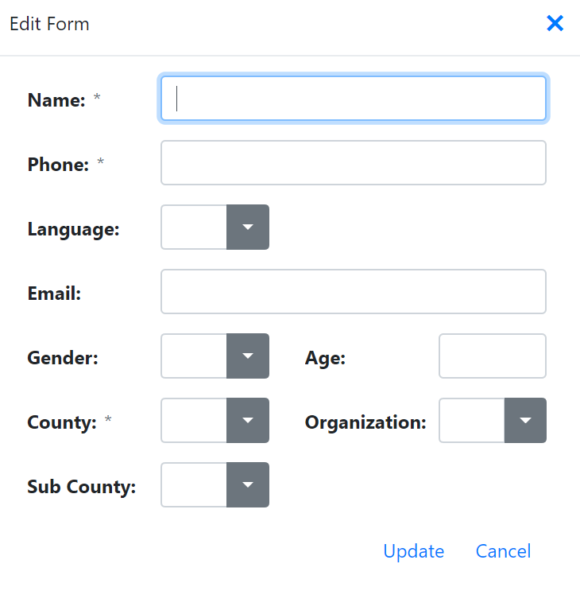

* Fill all the details and click on update.

## Editing contacts

Search for the contact to edit and click on the edit link on the left. A form like one below will appear.

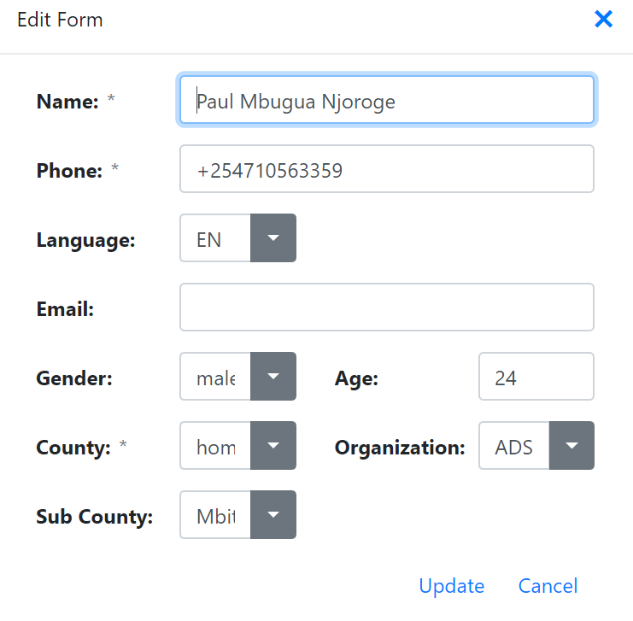

Edit the relevant information and update.

## Auto Registration

Relevant groups, individuals can self-register themselves by sending a registration sms to short code **20394**

The format for the registration is as follows

*Reg,[Full name],[Gender],Age[County],[Sub-county],[Organization]*

Example

*Reg,Paul M Ochieng,Male,23,Homabay,Mbita,ADS*

## Export Contacts

On the list of contact, filter as desired and click on *xls* or *xlsx* at the top to export the items to excel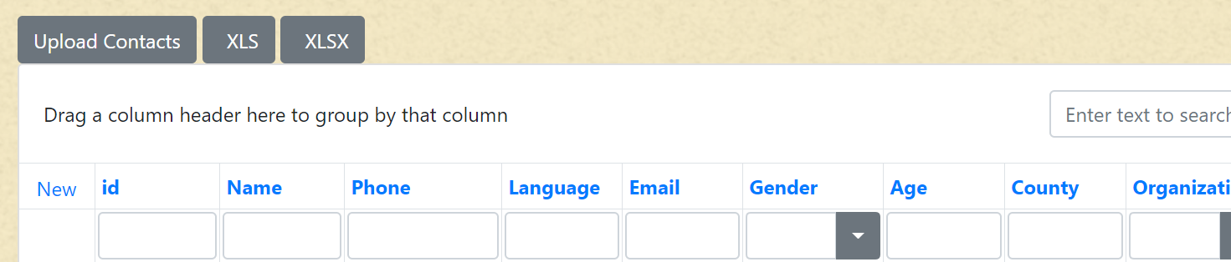

# Broadcast

This module is used to send smses to individual or group contacts

* Click on Broadcast>Broadcast to open a list of already sent broadcasts.

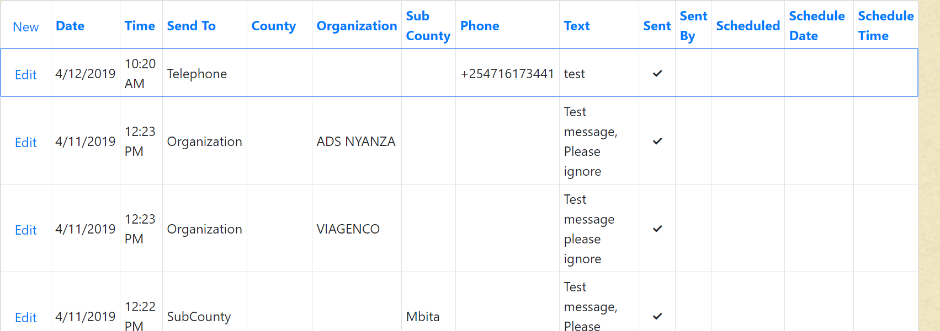

* On top left, click on new to create a new broadcast.

## Send broadcast

### To everyone

* To send an sms to everyone on the contacts select *Everyone* on the send To dropdown
* Enter the Text and click send.

### To a telephone Number

* To send an sms to a telephone number select *Telephone* on the send To dropdown
* Enter the phone number in the phone field, separated by commas (,).
* Enter the Text and click send.

### To an organization

* To send an sms to a contacts from a particular organization select *organization* on the send To dropdown
* Select the organization in the organization field
* Enter the Text and click send.

### To county contacts

* To send an sms to a contacts from a particular county select *county* on the send To dropdown
* Select the county in the county field
* Enter the Text and click send.

### To sub-county

* To send an sms to a contacts from a particular Sub-county select *Sub-County* on the send To dropdown
* Select the Sub-county in the Sub-county field
* Enter the Text and click send.

## Schedule Broad cast

* To schedule broad cast to be sent on a later date,
* Check on *scheduled.*
* Enter *Schedule date.*
* Enter *Schedule time.*
* Click on send.

## Sent Sms

This shows a list of all sent sms, to show this list

* Click on Broadcast > Sent sms

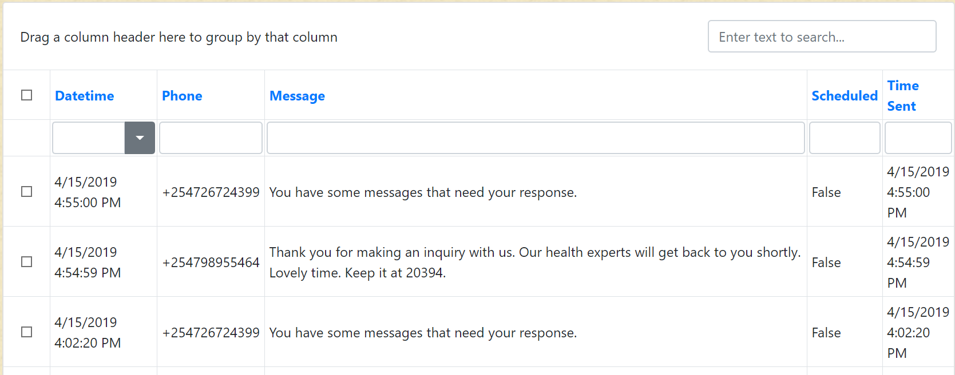

# Responses

This is used to setup automatic responses to incoming messages.

Click on responses to open the response list.

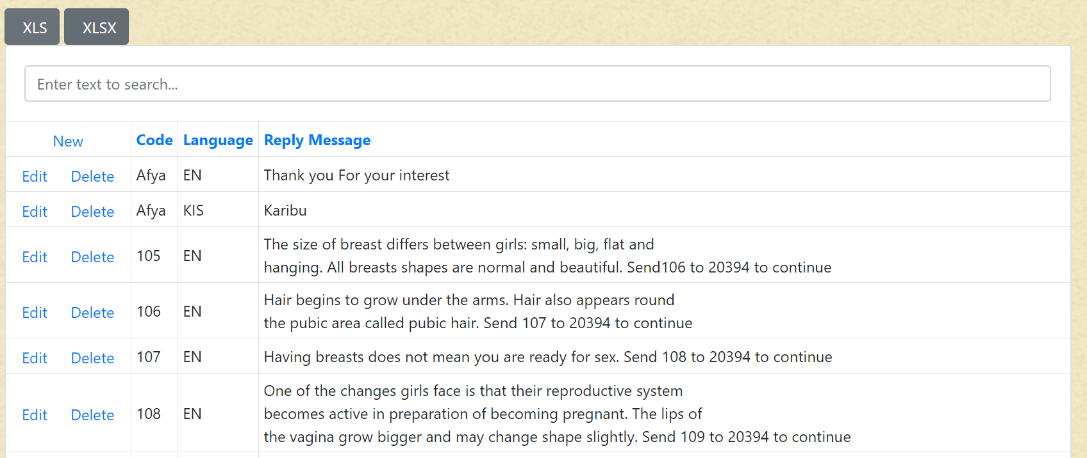

## Add a response

* Click on the new link on the left top of the list.
* The following form will appear.

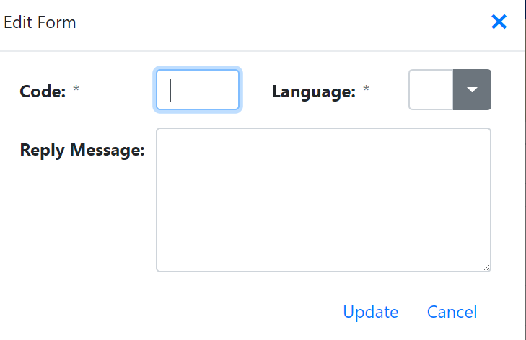

* Enter the code, language and Reply message.
* Click on update.

## Edit a response

* To edit a response, click on the edit link to the left of the response to edit.
* Edit the details as required then click on update.

# Queries/Incoming sms

This is the entry point for all smses to the platform

Click on Queries on the menu to see the list.

This will show the date, telephone of the sender name of the sender if in our contacts, the message received.

If the message has an automatic response, then this will be sent back to the contact, if it does not have an automatic response, a message will be sent to relevant agent for further response.

A custom response can be created by editing the message custom response.

# Settings

Here we setup several aspect regarding the platform

## Counties

* Click on settings > Organizations
* For adding/editing counties

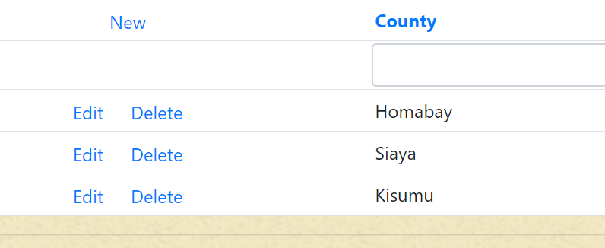

* To add a new county, click on the new link
* On the opened form enter the County name and update.

## Sub counties

* Click on settings > Sub counties

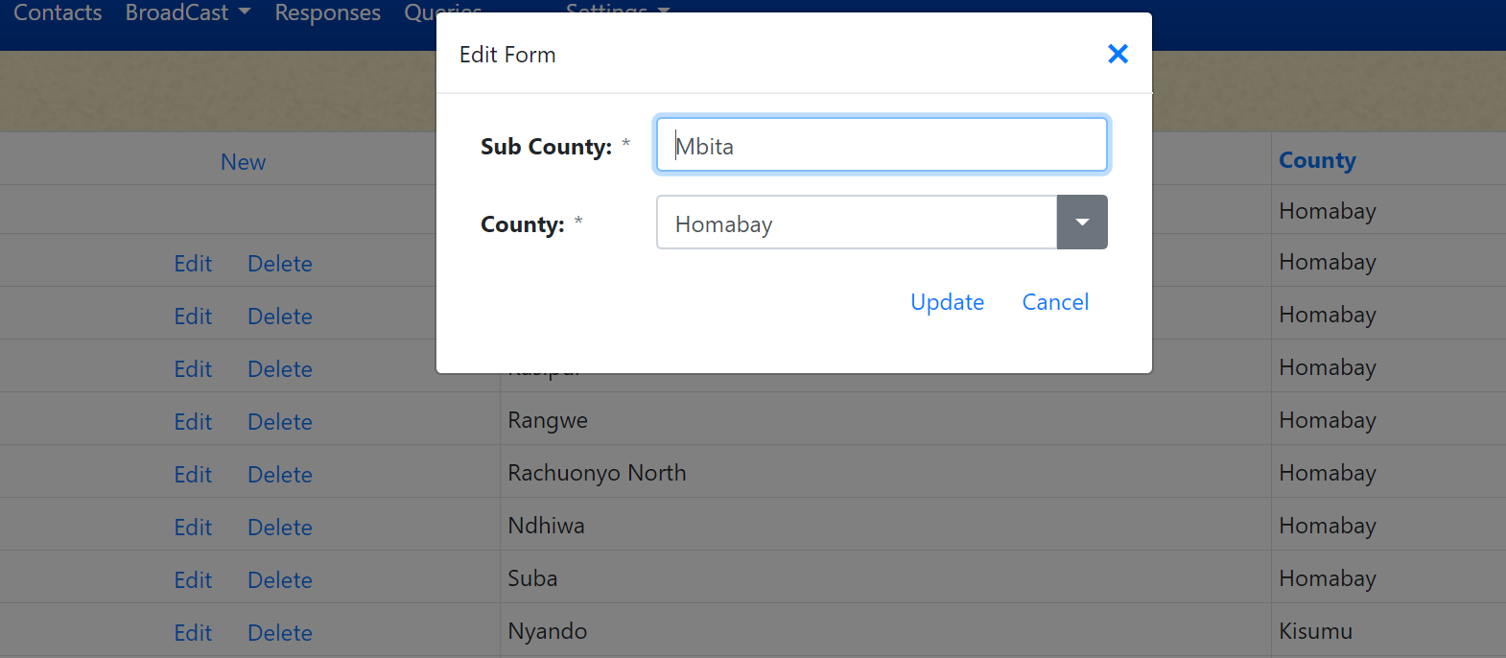

* To add a new Sub county, click on the new link
* On the form that appear, enter the Sub county name
* Select the corresponding County
* Click on update.

## Organizations

* Click on settings > Organizations

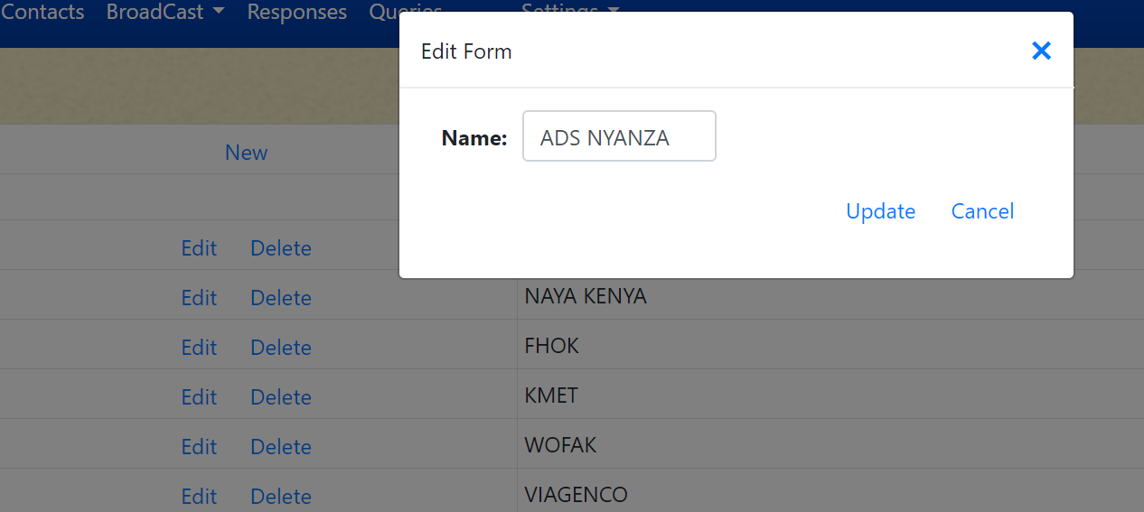

* To add an organization, click on the new link.
* Enter the name on the form that appear.
* Click on update.

## Languages

* Click on settings > Language

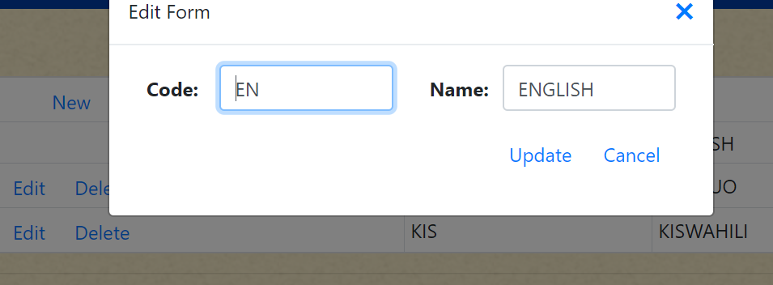

* To add new Language, click on new link.
* Enter the language code and language name.
* Click on update.

Other settings

* Click on settings > Language

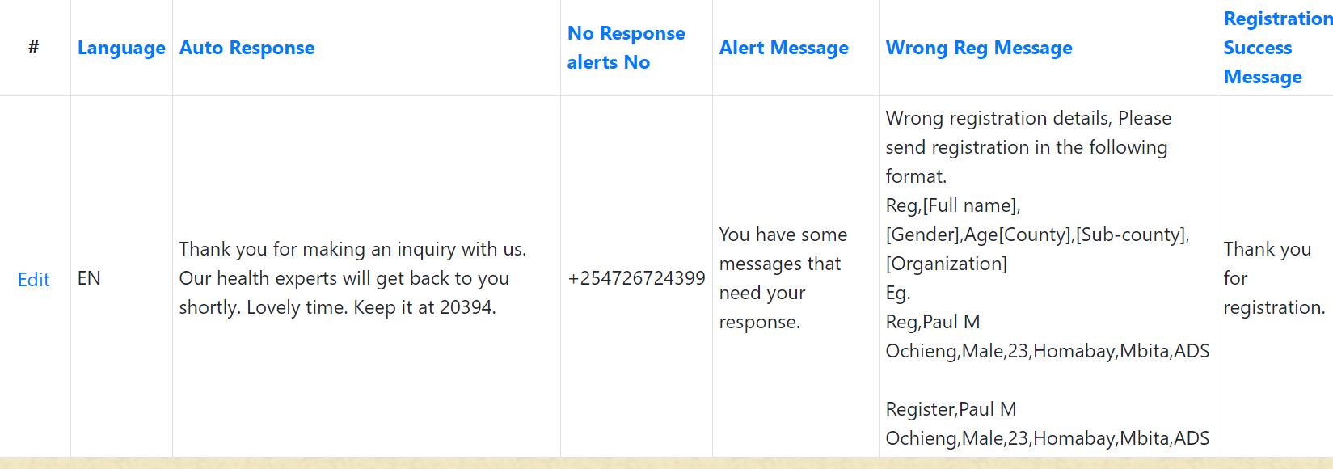

* Language –this is for default response language
* Auto Response – this is the response to queries that does not have auto response.
* No Response alerts No – Incase of queries with no auto response this is the number to be notified of such queries. Enter numbers separated by comma.
* Alert Message – the message to be sent incase of a query without auto response.
* Wrong Reg Message – Incase of wrong registration message this is the response to the contact.
* Registration success Message – Response on successful registration.